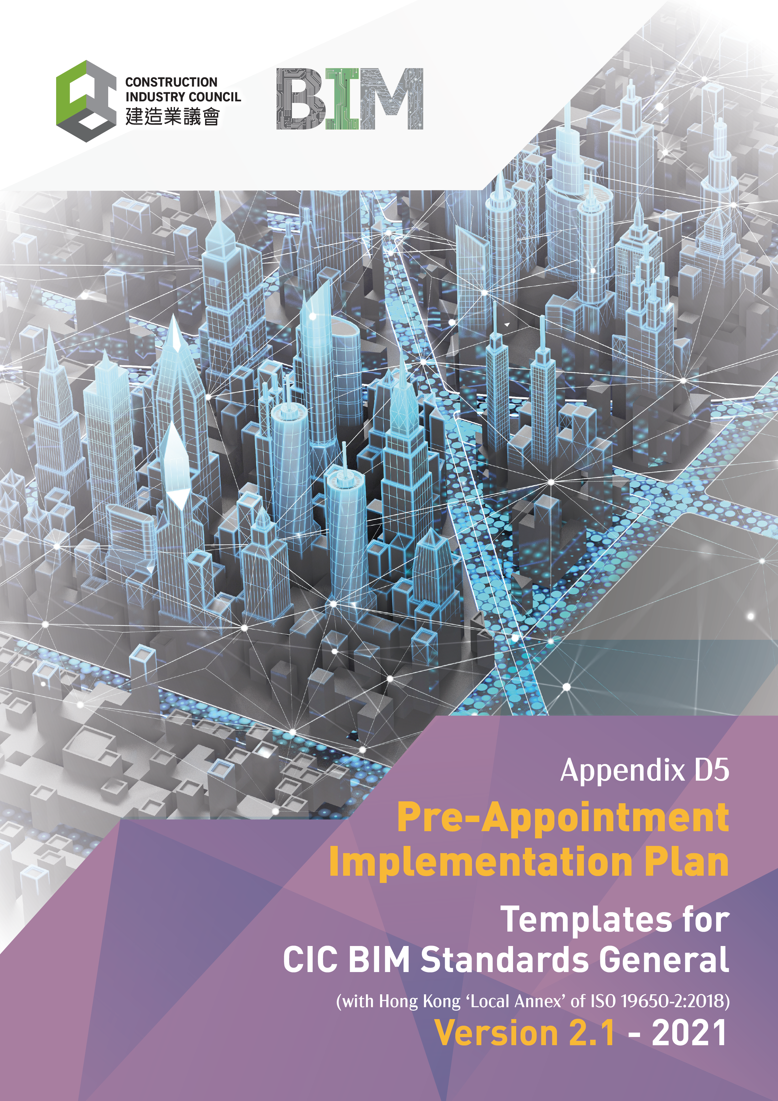

Document Revision Tracking
Issue Date | Notes
November 2021 | First Publication

Contents

Introduction 4
Purpose 4
1. Pre-Appointment BIM Implementation Plan 5
1.1 The Requirement 5
1.1.1 The Information Requirements 5
1.1.2 The Solution 5
2. Information requirements Responses 6
2.1 The Requirement 6
2.2 Organisational Information Requirements 6
2.3 Asset Information Requirements 6
2.4 Project Information Requirements 6
2.5 Project Milestones 7
2.6 Levels of Information Need 7
2.7 Acceptance Criteria 7
2.8 Exchange Information Requirements 7
2.9 Project Information Standards 8
2.10 Project Information Production Methods and Procedures 8
2.11 Project Reference Information 8
2.12 Project Shared Resources 8
2.13 Project Information Protocol 9
2.14 Additional Information Requirements 9
3. Pre-Appointment BIM Execution Plan 10
3.1 Pre-Appointment BIM Execution Plan documentation 10
4. Supporting Documentation 11
4.1 Capability Assessments 11
4.2 Capability Assessment Summary 11
4.3 High Level Responsibility Matrix 11
4.4 Risk Register 11
4.5 Mobilisation Plan 11
5. Other Information 12
5.1 Lead Consultant Information Requirements 12

Introduction

Purpose

The Appointing Party / Client shall “start with the end in mind” by providing or specifying the BIM Requirements, as identified in Table 1 Schedule of required Resources and Content defined under ISO 19650-1. These are basically the questions for the Lead Consultant / Lead Contractor as the Delivery Team Lead to understand what, when and how the Appointing Party / Client requires information to facilitate their decision-making requirements. The Pre-Appointment BIM Implementation Plan (BIM IP) will be the Delivery Team's initial answers to these questions providing a response to the Appointing Party's / Client’s BIM Requirements.

The Pre-Appointment BIM IP is a collection of the response documents such as the BIM Execution Plan, Mobilisation Plan, Capability Assessments, Risk Register, etc... that formulate the submission to the Appointing Party / Client for bidding on the project.
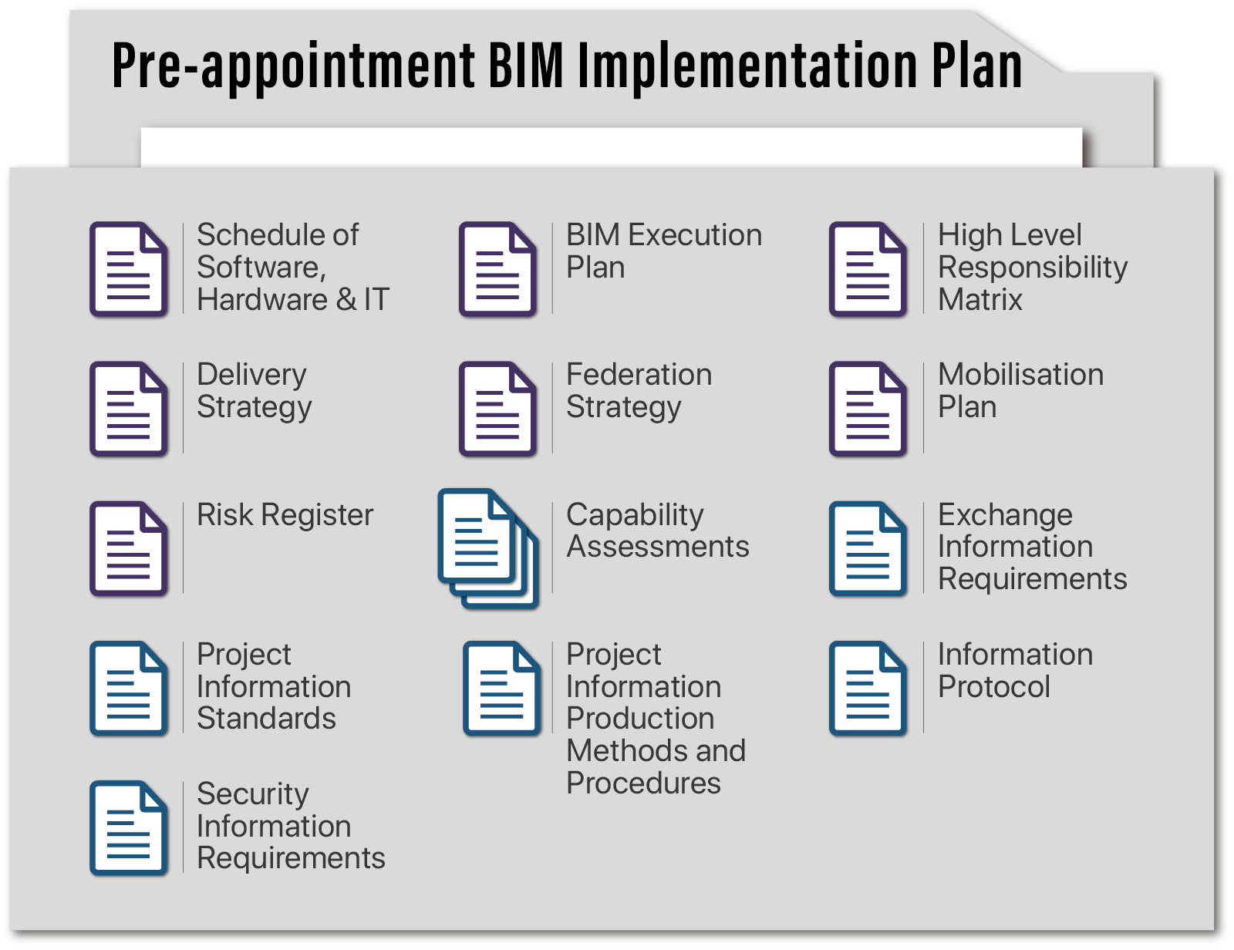
CIC BIM Standards – General Figure 14. Pre-Appointment BIM Implementation Plan (BIM IP) Contents

Therefore, each of the elements of the BIM Requirements provided will need to be taken on board and the contents of the Pre-appointment BIM IP should include responses.
The BIM Requirements and Pre-appointment BIM IP responses will then form the basis for the appointment or contract between the parties. A contract or appointment could be for design, construction or operation stages of the project life cycle requiring both BIM Requirements and a BIM Implementation Plan

- Pre-Appointment BIM Implementation Plan
  - The Requirement

The Pre-Appointment BIM Implementation plan provides the response to the Clients information Requirements and sets out the proposed approach and methodology to be adopted by the delivery team to deliver both the physical asset and the information requirements.

The Pre-Appointment implementation plan should be thought of as a folder which collects the series of documentation which make up the response to the information requirements. Depending upon the size and complexity of the project, the information response can be structured in many ways.

(On small to medium size projects the information may be predominantly produced inside the BIM Execution Plan. On larger projects with detailed Client’s documentation each element may exist as a document. The implementation plan should provide clarity how the response is structured by the delivery team for a specific project).

    - The Information Requirements

The Pre-Appointment implementation plan will include the responses to the Information requirements as chapter 2 and the delivery teams’ response which will include:
- Schedule of ICT (Software, Hardware, and IT Infrastructure)
- Delivery Strategy
- Risk Register
- Project Information Standards
- Project Information Security Requirements
- BIM Execution Plan
- Federation Strategy
- Capability Assessment
- Project Information Production Methods and Procedures
- High Level Responsibility Matrix
- Mobilisation Plan
- Exchange Information Requirements
- Project Information Protocol

The purposes of these information requirements are to identify what the Clients wants, how and when. Chapter one identifies who is provide a response to the Clients information requirements in order that the Client can assessed the proposed response approach from the delivery team.

    - The Solution
This document has been produced to enable all project team members to understand the proposed approach to information management and ensure that information is delivered and verified against the requirements identified. The project must support the aggregation of this information required to all parties.

- Information requirements Responses

The Pre-Appointment BIM Implementation plan provides the response to the Clients information Requirements and sets out the proposed approach and methodology to be adopted by the delivery team to deliver both the physical asset and the information requirements.
  - The Requirement
The Pre-Appointment implementation plan will include the responses to the following Information requirements and the initial chapter identifies where these responses are found.:
• Organisational information requirements;
• Asset information requirements;
• Project information requirements;
• Security information requirements;
• Project milestones;
• Exchange information requirements;
• Levels of information need;
• Acceptance criteria;
• Project information standards;
• Project information production methods and procedures;
• Project reference information;
• Project shared resources; and
• Project Information protocol.
  - Organisational Information Requirements

The general project information is as follows:
The Organisational information requirements document provided is:
(Provide document name)
The response to the Organisational information requirements is provided in:
(Provide document name and appropriate section information)

  - Asset Information Requirements

The following documents make up the information requirements against which define the basis for this implementation plan:
The Asset information requirements document provided is:
(Provide document name)
The response to the Asset information requirements is provided in:
(Provide document name and appropriate section information)
  - Project Information Requirements

The general project information is as follows:
The Project information requirements document provided is:
(Provide document name)
The response to the Project information requirements is provided in:
(Provide document name and appropriate section information)

  - Project Milestones

The general project information is as follows:
The Project milestones document provided is:
(Provide document name)
The response to the Project milestone requirements is provided in:
(Provide document name and appropriate section information)

  - Levels of Information Need

The following Organisations are identified as representatives of the Client on this project:
The Level of information need document provided is:
(Provide document name)
The response to the Level of information need document is provided in:
(Provide document name and appropriate section information)

  - Acceptance Criteria

This project functions undertaken on this project will be undertaken by:
The Acceptance criteria document provided is:
(Provide document name)
The response to the Acceptance criteria document is provided in:
(Provide document name and appropriate section information)

  - Exchange Information Requirements

This following identified project functions undertaken on this project will be undertaken by:
The Exchange information requirements document provided is:
(Provide document name)
The response to the Exchange information requirements is provided in:
(Provide document name and appropriate section information)

  - Project Information Standards

The project information standard is as follows:
The project information standard document provided is:
(Provide document name)
The response to the project information standard is provided in:
(Provide document name and appropriate section information)

  - Project Information Production Methods and Procedures

The project information production methods and procedures documentation provided is as follows:
The project information production methods and procedures document provided is:
(Provide document name)
The response to the project information production methods and procedures is provided in:
(Provide document name and appropriate section information)

  - Project Reference Information

The project reference information is as follows:
The project reference information provided is:
(Provide document name)
The response to the project reference information is provided in:
(Provide document name and appropriate section information)

  - Project Shared Resources

The Project shared resources and response is as follows:
The Project shared resources provided is:
(Provide document name)
The response to the Project shared resources is provided in:
(Provide document name and appropriate section information)

  - Project Information Protocol

The Project information protocol and response is as follows:
The Project information protocol document provided is:
(Provide document name)
The response to the Project information protocol is provided in:
(Provide document name and appropriate section information)

  - Additional Information Requirements

Details of additional information requirements provided (if any) and the response is as follows:
Additional information requirements document provided is:
(Provide document name)
The response to the additional information requirements is provided in:
(Provide document name and appropriate section information)

- Pre-Appointment BIM Execution Plan

(This template has been prepared on behalf of the CIC to enable projects to deliver their Building Information Modelling requirements in accordance with the CIC BIM Standards (General).)
This document is a response to the Clients Information Requirements and should be read in conjunction with the documentation identified in Chapter 2 as defining the information requirements.
(This document should be completed by the delivery team as part of a collaborative submission and reviewed with all key project stakeholders.)
The document requires the completion of the Clients Information requirements which are to be developed and completed with the assistance of the Design Team, Facilities Management and Operations team as well as other key stakeholders with an interest in or are possible beneficiaries of the BIM implementation plan.

  - Pre-Appointment BIM Execution Plan documentation

The main document providing the response to the information requirements is the Pre-Appointment BIM Execution Plan.

The Pre-Appointment BIM Execution Plan Templates used is:
CIC Pre-Appointment BIM Execution Plan Template
The Completed Pre-Appointment BIM Execution Plan is:
(Provide Document reference or insert here as appropriate)

- Supporting Documentation

  - Capability Assessments

(Insert capability assessments or reference)
The project capability assessments are:
(Provide document name if applicable:)

  - Capability Assessment Summary

(Insert capability assessment summary reference)
The capability assessment summary is:
(Provide document name if applicable:)

  - High Level Responsibility Matrix

(Insert high level responsibility matrix or reference)
The project responsibility matrix is:
(Provide document name if applicable:)

  - Risk Register

(Insert Delivery Team Risk Register)
The project risk register is:
(Provide document name if applicable:)

  - Mobilisation Plan

(Insert Mobilisation Plan)
The project mobilisation plan is:
(Provide document name if applicable:)

- Other Information

(This section provides an opportunity to provide additional information requirements or other supporting documentation proposed by the delivery team in relation to their proposals.)

  - Lead Consultant Information Requirements

(Insert Lead Consultant Information Requirements)
The Lead Consultant Information Requirements are:
(Provide document name if applicable:)

