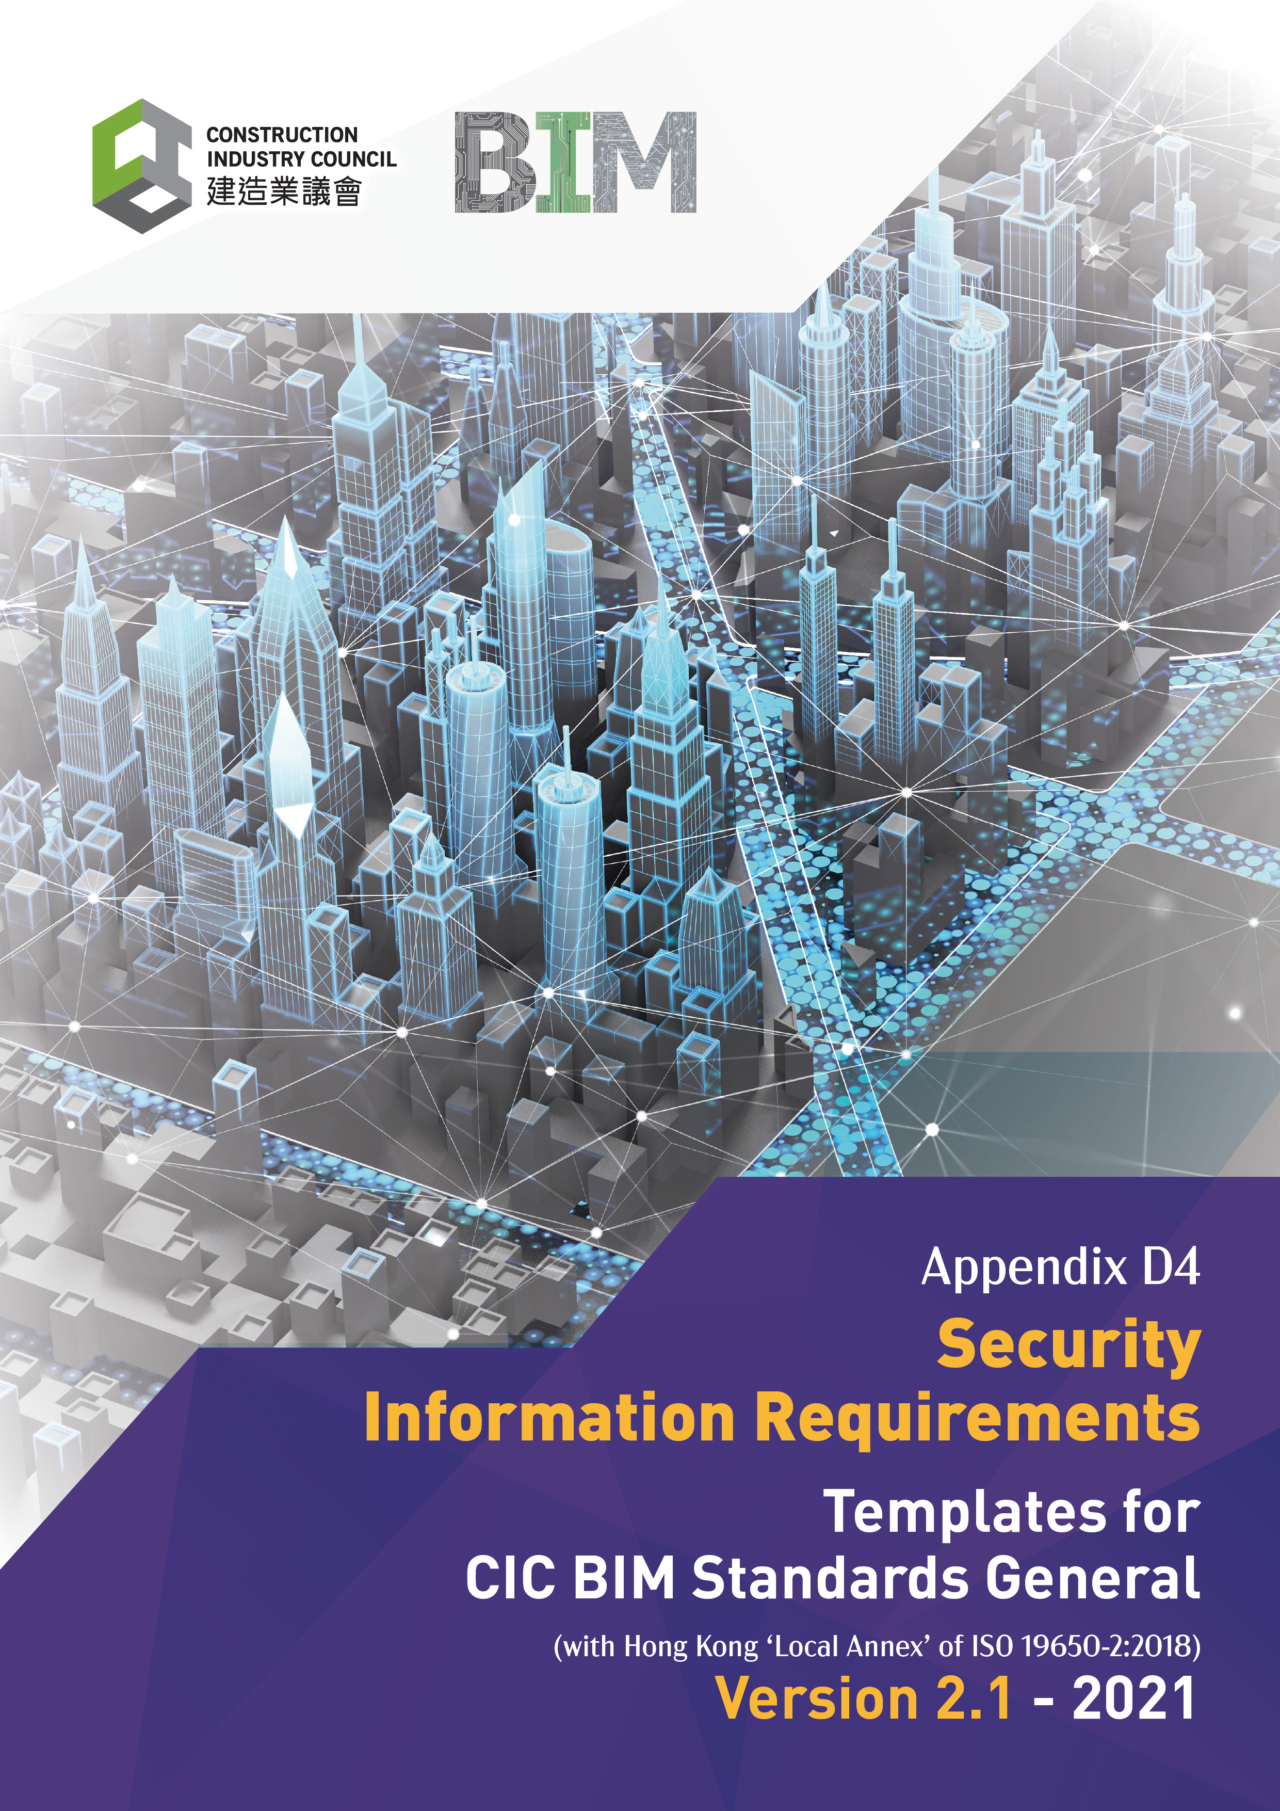

Document Revision Tracking
Issue Date | Notes
November 2021 | First Publication

Contents

Introduction 4
1. Security Information Requirements Overview 6
1.1 General Information 6
1.2 Security Information Management Functions 6
1.2.1 Management Functions 6
1.2.2 Security Access Clearance 7
1.2.3 Management Authorisations 7
1.2.4 Security Information Management Systems 7
1.3 Security policies and procedures 8
1.3.1 Security reference documentation 8
2. Security Requirements 9
2.1 Sensitivity Assessment process 9
2.2 Security risks 9
2.3 Security federation requirements. 9
2.4 Nomenclature and Obfuscation 10
2.5 BIM Object Security Information 10
3. Security 11
3.1 Security Risks 11
3.2 Security Mitigation Measures 11
3.3 Tolerated Security risks 11
3.4 Policies and procedures for security mitigation measures 12
3.5 Security Information sharing agreements 12

Introduction

Security Information Requirements

ISO 19650-5:2020 provides the basis for identifying the Security Information Requirements (SIR) in terms of what is a sensitive asset, product, or service, using the following criteria:
- Is part of the critical national infrastructure;
- Is a national security, defence, law enforcement or diplomatic function;
- Is a commercial site related to significant volumes of currency, valuable materials, pharmaceuticals, chemicals, petrochemicals, or gases;
- Is used or can be used to host events of security significance; and/or
- Constitutes a landmark, nationally significant site, or crowded place.

The Appointing Party / Client shall apply the security triage process as outlined in ISO 19650-5:2020 to establish whether a security-minded approach is required to the project, asset, or service. The outcome of the triage process should be documented within the information requirements and where required the appropriate actions and functions shall be put in place.
As illustrated in Figure 9, the triage process should identify whether the following action need to be undertaken depending upon the results:

1. Initiate the security-minded approach;
2. Develop a security strategy;
3. Develop a security management plan;
4. Develop a security breach/incident management plan; and
5. Work with appointed parties to implement any or all the above.

The Appointing Party / Client shall also develop a security strategy which shall include the outcome of the security triage process and follow the requirements of ISO 19650-5:2020.
Security Management Plan

Where a Security Management Plan is required it should set out the SIR for sharing and/or publishing of:
- New information;
- Modified information; or
- Existing information.
The Plan shall include whether these items relate to individual documents or the Information Model as a whole.

The Scope
The Asset Information Requirements (AIR) will include the following elements:
- Detailed Specification for delivery of Asset Information Model
- AIR Deliverables
- COBie
- Data Template requirements
The purposes of these documents are to clearly define the Appointing Party / Clients information requirements regarding Asset information in order that the Appointing Party / Client can procure a lifecycle data approach to information.
The Solution
The requirement is to continuously review, update and address any changing requirements through the course of the project.

This document has been produced in accordance with the CIC BIM Standards (General) to enable all delivery team members to work in a consistent manor and ensure that information is delivered and verified against the requirements identified. The project must support the aggregation of this information required all parties.

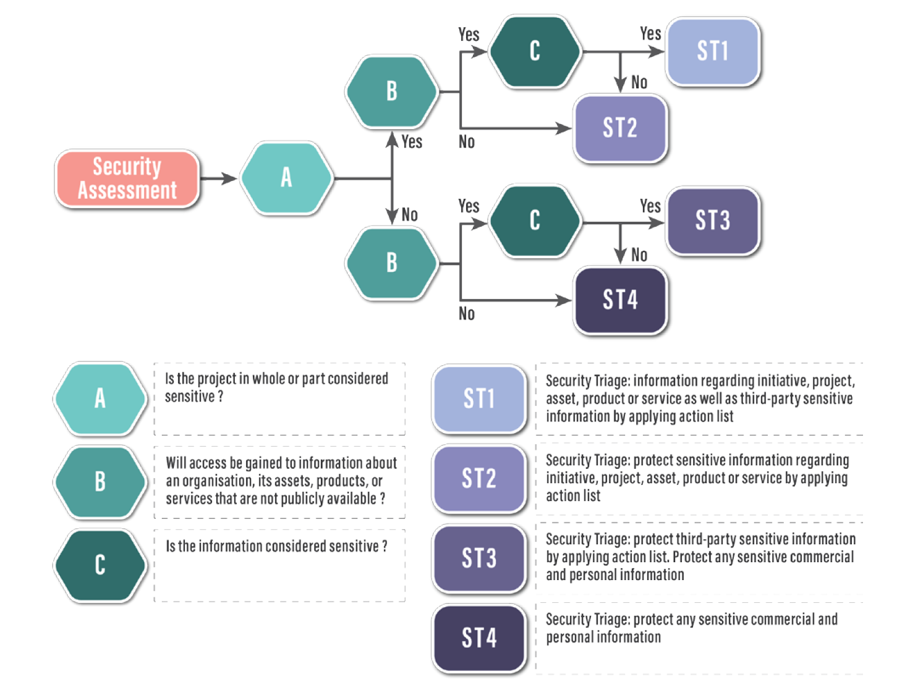
Figure 9 The Security Triage Process (CIC BIM Standards – General)
- Security Information Requirements Overview

The Security Information Requirements are a subset of the Appointing Party / Clients brief which set out the security requirements associated with information delivery for the duration of the project as well as the lifecycle of the asset.
The initial security requirements will be based upon the security triage process undertaken by the Appointing Party / Client. As a minimum the Security information requirements should identify that this triage process has been undertaken and the any required actions from the triage process.

  - General Information

This section sets out the people, technology and processes required for the security information requirements. These SIRs should be read in conjunction with the following Exchange Information Requirements (EIR):
Name | Document
Appointing Party / Clients EIR | CIC BIM Exchange Information Requirements (EIR) Template

(Following to be completed by the business’s representative.)

  - Security Information Management Functions

To be completed by the business’s representative.

    - Management Functions
This identified security management functions / responsibilities undertaken on this project will be undertaken by the following contacts:
Function / Responsibility | Name | Title / Role | Contact Details
Appointing Party / Client Delivery manager
Security Manager

    - Security Access Clearance
The project will identify the following project information access clearance identified security management functions will have the following project security authority:
Security Clearance | Identified Document demarcation
Unclassified
Public
Official
Secret
Top Secret

    - Management Authorisations

This identified security management functions will have the following project security authority:
Function / Responsibility | Name | Authority
Appointing Party / Client Delivery manager
Security Manager

    - Security Information Management Systems

The following are the current / proposed security management systems to be used along with the acceptable data formats:
Software application | Software vendor | Package | Version | File formats for delivery
Facilities management
Room bookings

  - Security policies and procedures

    - Security reference documentation

The following documents identified the security
Security Management Plans | Referenced document
Security management Policy
Cyber security policy
Cyber Resilience Policy
CDE security functional requirements

- Security Requirements

The delivery of Constructions Operations Building information exchange (COBie) is an internationally agreed format for the delivery of Asset information from Designers and Constructors for use by operators and maintainers. This section sets out the detailed requirements for delivery of COBie for the project.

  - Sensitivity Assessment process

There are multiple security risks that need to be considered in relation to the project and consideration should be given to the following:
Understanding range of risks
Identifying Organisational sensitivities
Establishing any third-party sensitivities
Recording the outcome of the sensitivity assessment
Reviewing the sensitivity assessment
Determining whether a security minded approach is required; and
Outcome of the Security triage process.

  - Security risks

There are multiple security risks that need to be considered in relation to the project and consideration should be given to:
- Potential Security Issues
- Range of threats that may seek to make use of vulnerabilities
- Range of traditional and evolving techniques of hostile reconnaissance
- Potential for components, individual Assets or products open to make use of vulnerabilities
- Potential for malicious acts caused by a range of external or internal threats; and
- Reputational risk rising from the issues above.

  - Security federation requirements.

Depending upon the results of the triage process the models may need to be federated using identified security zones or specific systems dependent upon identified security risk. The following table sets of the security federation requirements;
Zone or System name | Identifier | Security rating
CCTV | CTV | Secret

  - Nomenclature and Obfuscation

For identified security risks obfuscation can be used as a technique for separating documentation from the associated data key. The following items are considered at specific risk and therefore obfuscation risks shall be included in all documentation:
Zone or System name | Identifier | Security rating
CCTV | CTV | Secret

  - BIM Object Security Information

To deliver a secure model information security restriction, need to be put in place regarding the following object types:
Object Type | Security rating | Restriction
CCTV | Secret | Generic locations and routing only shall be indicated

- Security

The delivery of Constructions Operations Building information exchange (COBie) is an internationally agreed format for the delivery of Asset information from Designers and Constructors for use by operators and maintainers. This section sets out the detailed requirements for delivery of COBie for the project
(The content of the COBie section can be delivered in different formats and this section identifies the appropriate approached that can be made.)

  - Security Risks
The Table identifies specific security risk information which provided in the following format:
Security Risk | Risk Level | Risk Owner
(Presentation materials) | (Confidential) | (Security Manager)

  - Security Mitigation Measures

The following Table sets out the security mitigation measures that shall be incorporated:
Security Risk | Risk Owner | Mitigation Measure

  - Tolerated Security risks

The identified tolerated security risk has been identified as follows:
Security Risk | Risk Owner | Description

  - Policies and procedures for security mitigation measures

The identified policy and procedures documents for security mitigation measures are identified as:
Procedure | Security Level | Document / Description

  - Security Information sharing agreements

An information sharing agreement available to all parties should be put in place prior to the sharing of any sensitive information that can be used to cause harm as identified in the Security management plan.
Agreement | Parties | Date

