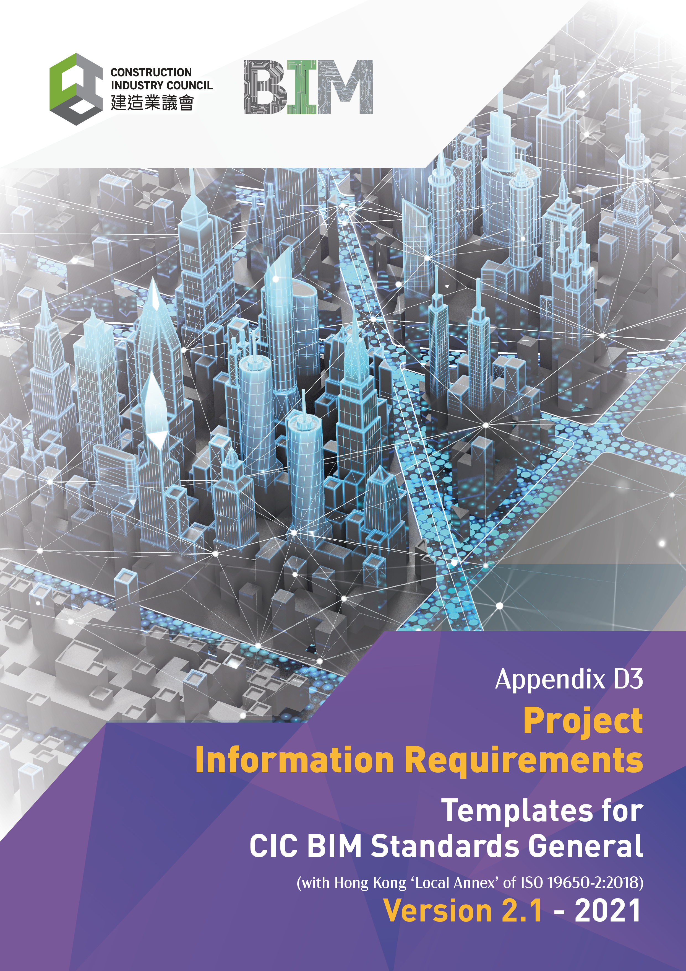

Document Revision Tracking
Issue Date | Notes
November 2021 | First Publication

Contents

Introduction 4
1. Project Information Requirements 5
1.1 General Information 5
1.1.1 Appointing Party / Client Project Information Management Functions 5
1.1.2 Project Information Management Systems 5
1.2 Quality assurance procedures 6
1.2.1 Quality Systems 6
2. Project Requirements 7
2.1 The Project Scope 8
2.2 BIM Uses 8
2.3 Project Plan of works 8
2.4 Procurement route and process 8
2.5 Milestones and decision points 8
2.6 Appointing Party / Client’s decision and response requirements 8
3. Information Requirements 9
3.1 Capital investment and life cycle costing requirements 9
3.2 Health and safety compliance and management requirements 10
3.3 Security management requirements 10
3.4 Emergency management and contingency planning requirements 10
3.5 Environmental management requirements 10
3.6 Sustainability requirements 10
3.7 Supply chain management requirements 11
3.8 Space utilisation requirements 11
3.9 Risk assessment and management requirements 11
3.10 Maintenance and repairs requirements 11
3.11 Asset modifications requirements 11
3.12 Asset operations requirements 12
3.13 Human resources, skills development, training, and competencies requirements 12
3.14 Technologies adoption requirements; and 12
3.15 Value management requirements. 12

Introduction

Project Information Requirements

Project Information Requirements (PIR) should explain the information needed to either answer or inform high-level strategic objectives that the Appointing Party / Client may have in relation to the design and delivery of each project. The PIR should take on board the life cycle requirements of projects, including the project management and asset management processes.

In formulating the PIR, the Appointing Party / Client should consider the following:
- The project scope;
- BIM Uses;
- Project Plan of work;
- Procurement route and process;
- Appointing Party's / Client’s milestones and decision points; and
- The Appointing Party's / Client’s decision and response requirements.

The PIR should be project- and stage-specific and prepared against each of the Appointing Party's / Client’s key decision points. The PIR can also include within its contents:
- Organisational key performance indicators;
- Strategic briefing requirements;
- Business case needs (e.g., Project Return on Investment (ROI));
- Project specific tasks required by the Appointing Party / Client; and
- Identified Project Stakeholders.

The PIR can exist as a separate document or can be included with the Appointing Party's / Client’s briefing documentation or Exchange Information Requirements (EIR). The PIR cascade should be noted, i.e., a Lead Appointed Party’s PIR should be produced taking on board their requirements and either enhancing or replacing the Appointing Party / Client within the Lead Consultant’s / Lead Contractor’s PIR.

The Scope
The PIR will include the following elements:

The Solution
The requirement is to continuously review, update and address any changing requirements through the course of the project.

This document has been produced to enable all delivery team members to work in a consistent manor and ensure that information is delivered and verified against the requirements identified. The project must support the aggregation of this information required all parties.
- Project Information Requirements

The Project Information Requirements should be read in conjunction with the project Exchange Information Requirements and the Asset Information Requirements.
  - General Information

To be completed by the business’s representative.

    - Appointing Party / Client Project Information Management Functions

This project functions (roles and responsibilities) identified on this project will be undertaken by:
Function | Name | Company | Contact Details
Appointing Party / Client Delivery manager
Appointing Party / Client Information Manager
Security Information Manager

    - Project Information Management Systems

The following are the current / proposed Appointing Party / Client project management systems to be used along with the acceptable data formats:
Software application | Software vendor | Package | Version | File formats for delivery
Project management solution
Common Data Environment |  |  |  | .pdf / .dwg / .rvt / .xlsx / .nwc / .ifc

  - Quality assurance procedures

    - Quality Systems

The following processes and quality systems are in place to support the definition and delivery of project Information in accordance with these Project Information Requirements.
Quality Procedures | Documentation document name

(Identified Quality processes and quality systems identified should be included within any project information standards or project information production methods and procedures as relevant).

- Project Requirements

The delivery of information to aid Appointing Party / Client decision making is a fundamental requirement of these Project Information Requirements and provides an internationally agreed format for the delivery of project information from Designers and Constructors for use by Appointing Party / Clients and their representatives. This section sets out the detailed requirements for delivery of information for the project.
In formulating the PIR, the Appointing Party / Client should consider the following:
- The project scope;
- BIM Uses;
- Project Plan of work;
- Procurement route and process;
- Appointing Party's / Client’s milestones and decision points; and
- The Appointing Party's / Client’s decision and response requirements.

The PIR should be project- and stage-specific and prepared against each of the Appointing Party's / Client’s key decision points. The PIR can also include within its contents:
- Organisational key performance indicators;
- Strategic briefing requirements;
- Business case needs (e.g., Project Return on Investment (ROI));
- Project specific tasks required by the Appointing Party / Client; and
- Identified Project Stakeholders.

Each information requirement should be defined either in a separate document or as a series of input statements identified to meet each requirement set. Where possible requirements should have a Unique ID, an owner, data format and acceptance criteria. They may also include supporting information for clarification.

Example requirement input statement
Requirement
Requirement ID | Requirement Owner |  | Requirement Data Format |  | Acceptance Criteria |  | Supporting Information
What is the building floor area for occupancy calculation purposes?
2.12.001 | Building Officer | Area m2 |  | Direct from model / area schedule |  | Area to be calculated as net usable floor area, not including circulation space (stairs and corridors) toilets, plant rooms etc…
  - The Project Scope
The Project scope requirements is identified as follows:
Project Scope
(Reference document or input statement)

  - BIM Uses

The proposed project BIM uses should be identified in Section 4 of the Exchange Information Requirements as identified below:
BIM Uses
(Reference document or input statement)

  - Project Plan of works

To proposed Project Plan of Works to be used are identified as:
Project Plan of works
(Reference document or input statement)

  - Procurement route and process

The proposed project Procurement route and process are identified as:
Procurement route and process
(Reference document or input statement)

  - Milestones and decision points

The Appointing Party / Clients milestones and decision points are identified as:
Milestone and decision points
(Reference document or input statement)

  - Appointing Party / Client’s decision and response requirements

The Appointing Party / Clients decision and response requirements are identified as:
Appointing Party / Clients’ decision and response requirements
(Reference document or input statement)

- Information Requirements

The following information requirements are identified from the OIRs as information required to asset the Appointing Party / Client Organisation in making better decisions. The structure of these is based upon the identified OIR structure defined within the CIC BIM Standard General and included within Section 3 of the CIC OIR Template. The structure of this may be changed to meet an organisations information need.
The Organisation has identified the following information requirements to facilitate compliance with each of the organisations policy documents.
Each information requirement should be defined either in a separate document or as a series of input statements identified to meet each requirement set. Where possible requirements should have a Unique ID, an owner, data format and acceptance criteria. They may also include supporting information for clarification.

Example requirement input statement
Requirement
Requirement ID | Requirement Owner |  | Requirement Data Format |  | Acceptance Criteria |  | Supporting Information
What is the building floor area for occupancy calculation purposes?
2.12.001 | Building Officer | Area m2 |  | Direct from model / area schedule |  | Area to be calculated as net usable floor area, not including circulation space (stairs and corridors) toilets, plant rooms etc…

(Identifying what, how, where and when this information is required will aid with information delivery and the proposed approach to supporting the information needs to aid decision making.)
Against each information requirement a delivery date should be identified either as a relative date or specific date.
  - Capital investment and life cycle costing requirements

The Organisation Capital investment and lifecycle costing requirements is identified as follows:
Capital Investment requirements
(Reference document or input statements)
Lifecycle costing requirements
(Reference document or input statements)

  - Health and safety compliance and management requirements

The Organisations Health and safety compliance and management requirements is identified as follows:
Health and safety compliance
(Reference document or input statements)
Health and safety management
(Reference document or input statements)

  - Security management requirements

The Organisations security management requirements is identified as follows:
Capital Investment requirements
(Reference document or input statements)

  - Emergency management and contingency planning requirements

The Organisations emergency management and contingency planning requirements are identified as follows:
Emergency management requirements
(Reference document or input statements)
Contingency planning requirements
(Reference document or input statements)

  - Environmental management requirements

The Organisations environmental management requirements is identified as follows:
Environmental management requirements
(Reference document or input statements)

  - Sustainability requirements

The Organisations sustainability requirements is identified as follows:
Sustainability requirements
(Reference document or input statements)

  - Supply chain management requirements

The Organisations supply chain management requirements is identified as follows:
Supply Chain management requirements
(Reference document or input statements)

  - Space utilisation requirements

The Organisations health and safety compliance and management requirements is identified as follows:
Capital Investment requirements
(Reference document or input statements)
Lifecycle costing requirements
(Reference document or input statements)

  - Risk assessment and management requirements

The Organisations risk assessment and management requirements is identified as follows:
Risk assessment requirements
(Reference document or input statements)
Risk management requirements
(Reference document or input statements)

  - Maintenance and repairs requirements

The Organisations maintenance and repairs requirements is identified as follows:
Maintenance requirements
(Reference document or input statements)
Repair’s requirements
(Reference document or input statements)

  - Asset modifications requirements

The Organisations asset modification requirements is identified as follows:
Asset modification requirements
(Reference document or input statements)
  - Asset operations requirements

The Organisations health and safety compliance and management requirements is identified as follows:
Asset Operations requirements
(Reference document or input statements)

  - Human resources, skills development, training, and competencies requirements

The Organisations human resources, skills development, training, and competencies requirements is identified as follows:
Human Resources requirements
(Reference document or input statements)
Skills Development requirements
(Reference document or input statements)
Training requirements
(Reference document or input statements)
Competency requirements
(Reference document or input statements)

  - Technologies adoption requirements; and

The Organisations technology adoption requirements is identified as follows:
Technology adoption requirements
(Reference document or input statements)

  - Value management requirements.

The Organisations value management requirements is identified as follows:
Value management requirements
(Reference document or input statements)

