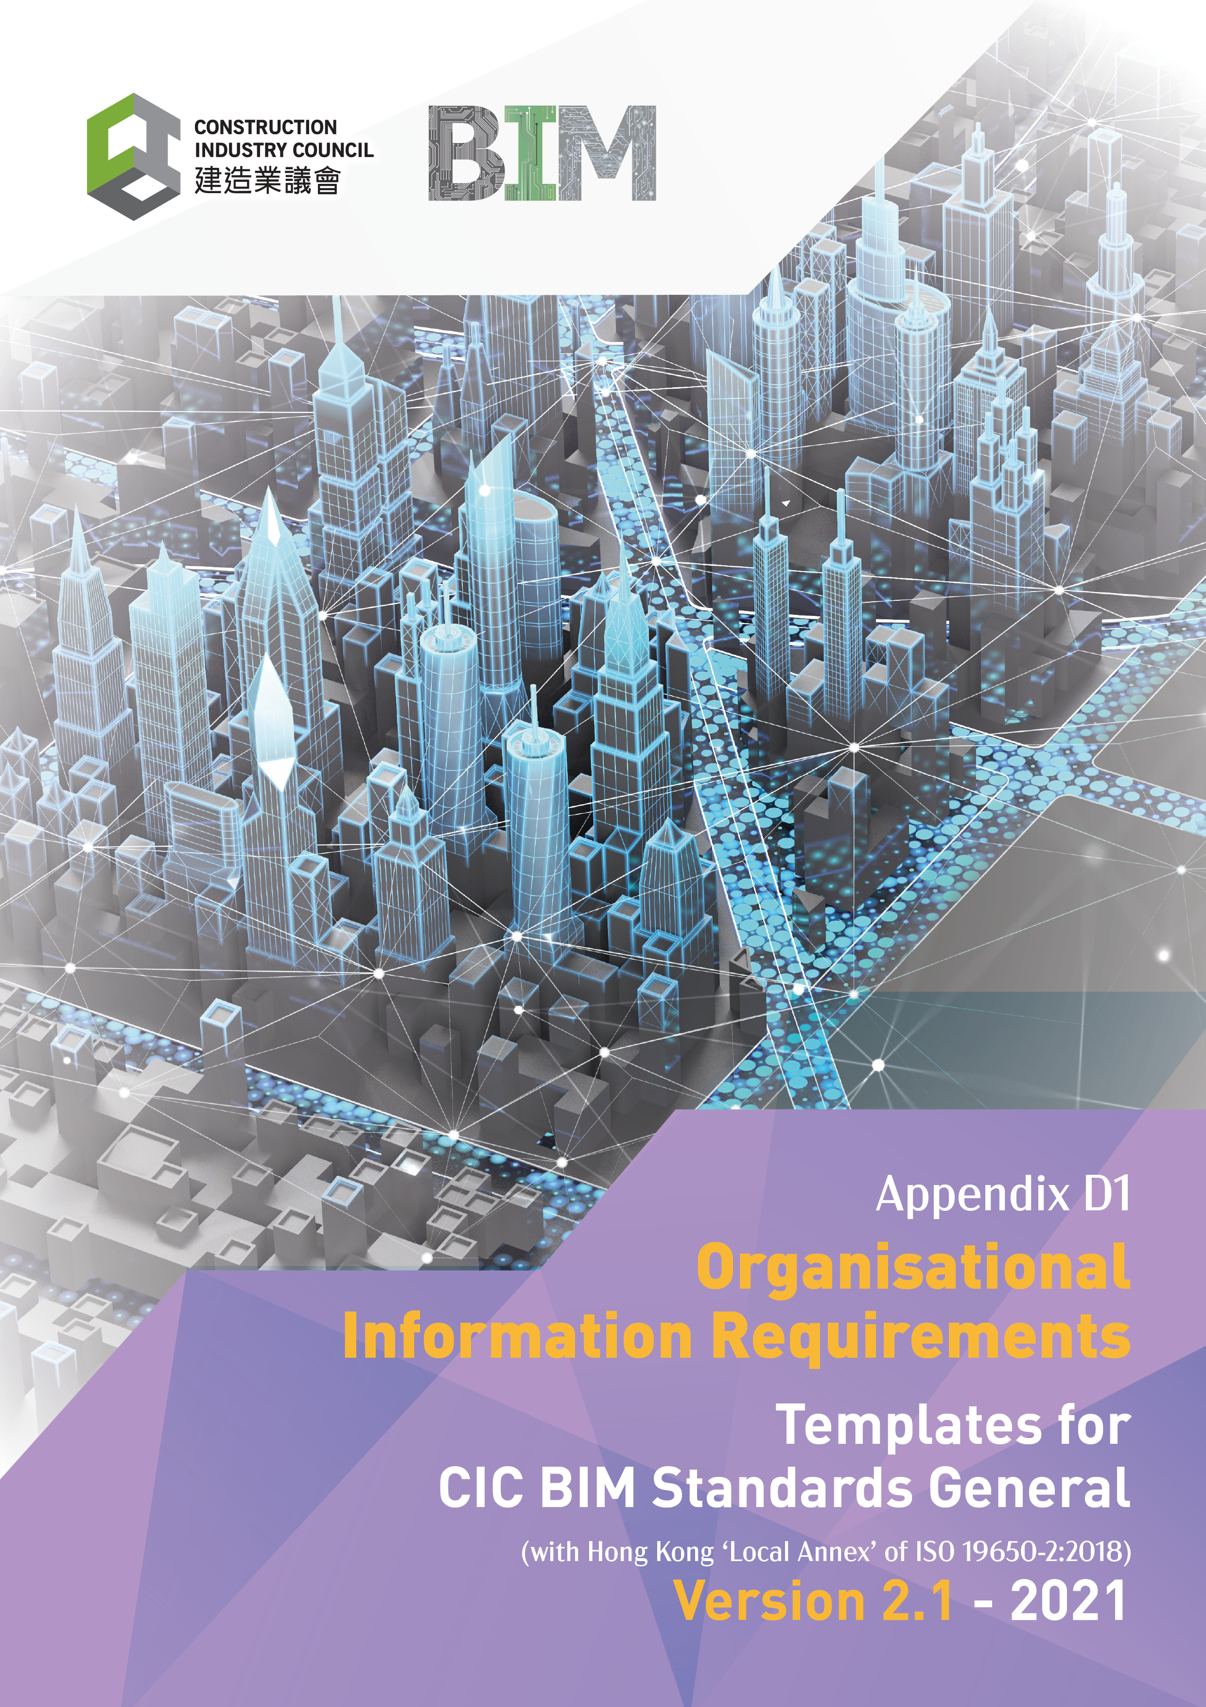

Document Revision Tracking
Issue Date | Notes
November 2021 | First Publication

Contents

Introduction 4
1. Organisational Information Requirements (OIR) in General 5
1.1 General Information 5
1.1.1 Organisation Management Functions (Roles and responsibilities) 5
1.1.2 Organisation Management Systems 6
1.2 Quality assurance procedures 6
1.2.1 Quality Systems 6
2. Organisation Policies 7
2.1 Capital investment and life cycle costing policy 8
2.2 Health and safety compliance and management policy 8
2.3 Security management policy 8
2.4 Emergency management and contingency planning policy 9
2.5 Environmental management policy 9
2.6 Sustainability policy 9
2.7 Supply chain management policy 10
2.8 Space utilisation policy 10
2.9 Risk assessment and management policy 10
2.10 Maintenance and repairs policy 11
2.11 Asset modifications policy 11
2.12 Asset operations policy 11
2.13 Human resources, skills development, training, and competencies policy 12
2.14 Technologies adoption policy; and 12
2.15 Value management policy. 12
3. Organisation Information Requirements 14
3.1 Capital investment and life cycle costing requirements; 14
3.2 Health and safety compliance and management requirements; 15
3.3 Security management requirements; 15
3.4 Emergency management and contingency planning requirements; 15
3.5 Environmental management requirements; 15
3.6 Sustainability requirements; 15
3.7 Supply chain management requirements; 16
3.8 Space utilisation requirements; 16
3.9 Risk assessment and management requirements; 16
3.10 Maintenance and repairs requirements; 16
3.11 Asset modifications requirements; 16
3.12 Asset operations requirements; 16
3.13 Human resources, skills development, training, and competencies requirements; 17
3.14 Technologies adoption requirements; and 17
3.15 Value management requirements. 17

Introduction

Organisational Information Requirements

Organisational Information Requirements (OIR) are aimed predominantly at defining the information required by an organisation to answer or inform high-level strategic objectives rather than asset level or project specific objectives. An OIR can be defined at multiple tiers of an organisation’s hierarchy and based upon a wide range of organisational activities. The intention is to allow the cascading of requirements down through organisations and the flow of information up these tiers to inform decision making. The requirements may be needed for multiple decision making, which can include:

- Policy decisions;
- Portfolio planning;
- Regulatory obligations;
- Strategic asset management; and
- Strategic business operations.

The high-level activities which may need to be considered in formulating OIR can include, but are not limited to:
- Capital investment and life cycle costing;
- Health and safety compliance and management;
- Security management;
- Emergency management and contingency planning;
- Environmental management;
- Sustainability;
- Supply chain management;
- Space utilisation;
- Risk assessment and management;
- Maintenance and repairs;
- Asset modifications;
- Asset operations;
- Human resources, skills development, training, and competencies;
- Technologies adoption; and
- Value management.

To facilitate a digital approach for decision making, the OIR should be developed in a manner to enable a digital approach. This will facilitate data verification and defining support solutions.

The Solution
The Organisation Information Requirements should be continuously reviewed, updated, and address any changing requirements as an organisation develops its processes and business thinking.

This document has been produced to enable all delivery team members to understand the Appointing Party / Client Organisations information requirements and work in a consistent manor and ensure that information is delivered and verified against the requirements identified. The project must support the aggregation of this information required by all parties.

- Organisational Information Requirements (OIR) in General

The Organisational Information Requirements (OIR) set out the information that the Appointing Party / Clients Organisation needs for both business and strategic decision making during an Assets delivery, as well as its operation and lifecycle. This section sets out the general information requirements to ensure information is defined in using a consistent approach.
(To be completed by the business’s representative.)

  - General Information
The Organisations information and main contact in relation to these Organisation requirements is identified below:
Organisation Name | (Add Organisation Name)
Organisation Address | (Add Organisation Address)
Organisation Section / Team | (Add Organisation section or team information if applicable)
Main Contact | (Add Contact Name)
Contact phone | (Add Contact phone number)
Contact email | (Add Contact email address)

    - Organisation Management Functions (Roles and responsibilities)
The following have contributed to the organisation information requirements (OIR) and may be identified as requirement owners. Further information or clarification may be needed from the following:
Function (Role / Responsibility) | Name | Company | Contact Details
(Organisation management functions identified should be included within any project information requirements or exchange information requirement created for specific projects.)
    - Organisation Management Systems
The following are the current / proposed management solutions, asset, operations, and facilities management systems to be used along with the acceptable data formats:
Software application | Software vendor | Package | Version | File formats for any delivery
(Identified Quality processes and quality systems should identify specifying information delivery formats for inclusion within the exchange information requirements).

  - Quality assurance procedures

    - Quality Systems

The following processes and quality systems are in place to support the definition and delivery of Asset Information in accordance with these Organisational Information Requirements.
Quality Procedures | Documentation document name
(ISO 9001 Processes)
(ISO 27001 Processes)
(Identified Quality processes and quality systems should be included within any project information standards or project information production methods and procedures as relevant).

- Organisation Policies

The Organisation Information Requirements provide an internationally agreed format for Organisations to identify what and how they want information to meet the needs in relation to their built assets for the benefit of their business. Information from Designers and Constructors can not only be used by operators and maintainers but can also aid with other Appointing Party / Clients business needs if understood and can provide support to existing organisation policies.

(This section sets out any identified requirements to aid with
- Policy decisions;
- Portfolio planning;
- Regulatory obligations;
- Strategic asset management; and
- Strategic business operations.)

The Organisation Information requirements identified refer to physical or built assets, but other information requirements may establish other aspects.
The purpose of this Template is to aid Organisations in the definition of their Organisation Information requirements. Section 2 identifies the Organisation policies against which the information requirements will be defined. Section 3 sets out the specific information requirements requested to support the policies identified in Section 2.

(NOTE:
There is not specific need for Appointing Party / Clients to issue the OIRs as an identified document for individual projects. Also, the purposes and reasons for requiring information do not have to be passed on to the delivery teams as part of any information requirements. The Asset Information Requirements, Project Information Requirements and Exchange information requirements should be populated from the outcomes of this OIR as identified in Section 3 to ensure that the information requirements are met. )
  - Capital investment and life cycle costing policy
(The capital investment and life cycle costing requirements should include an organisations policy that set out business goals and requirements.
Examples of these could include:
- Strategic Asset Management Portfolio requirements including financial actuals, full year, and project forecasts to be delivered monthly.
- Lifecycles costing information requirements settings out asset lifecycle, capital costs, maintenance costs, resource requirements, and replacement to establish best value.)

The organisation capital investment and lifecycle costing policy are identified as follows:
Capital investment policy
(Reference document or input statement)
Lifecycle costing policy
(Reference document or input statement)

  - Health and safety compliance and management policy

(The health and safety compliance and management requirements should include a policy detailing the organisations approach to health and safety. This should establish the aims and objectives, as well as defining ownership and responsibility. It should establish the approach to health and safety matter and confirm the organisations approach and commitment, therefore promoting safe working practice
Examples of these could include:
- Good Practice on preventative measure against COVID 19
- Lifting Safety requirements.)

The organisations health and safety compliance and management policy are identified as follows:
Health and safety policy
(Reference document or input statement)
Health and safety management policy
(Reference document or input statement)

  - Security management policy
(The security management requirements should include a policy detailing the organisations approach to both physical and information security. This should establish the aims and objectives, as well as defining ownership and responsibility.
Examples of these could include:
- Requirements for all cloud-based solutions to be in accordance with ISO 27000 and stored on a Hong Kong based server.
- All projects to undertake a security triage process prior to commencement.)

The Organisations security management policy is identified as follows:
Security management policy
(Reference document or input statement)

  - Emergency management and contingency planning policy
(The emergency management and contingency planning policy should set out business needs for information requirements necessary if an immediate risk or threat requires urgent attention.
Examples of these could include:
- Evacuation requirements;
- Response to Medical incident;
- Response to Fire; and
- Response to a terrorist event.)

The Organisations emergency management and contingency planning policy are identified as follows:
Emergency management policy
(Reference document or input statement)
Contingency planning policy
(Reference document or input statement)

  - Environmental management policy
(The environmental management policy should set out business needs for information requirements necessary to support the environmental management approach.
Examples of these could include:
- Monitor legal duties and statutory obligations
- Minimise waste generated from construction and operations;
- Minimise energy consumption generated from construction and operations;
- Identified measurable target for improving environmental performance; and
- Use of reduction in energy use.)

The Organisations environmental management policy is identified as follows:
Environmental management policy
(Reference document or input statement)

  - Sustainability policy

(The sustainability policy should set out business needs for information requirements necessary to support the sustainability approach.
Examples of these could include:
- BEAM Plus compliance requirements
- Monitor legal duties and statutory obligations
- Use of materials from sustainable sources
- Prioritise sustainability initiatives; and
- Participate in circular economy approach.)

The Organisations sustainability policy is identified as follows:
Sustainability policy
(Reference document or input statement)
  - Supply chain management policy
The supply chain management policy should set out business needs for information requirements necessary for supply chain procurement and management.
Examples of these could include:
- Compliance with legal duties and statutory obligations;
- Modern Slavery policy;
- Ethical working policy;
- Demand Management;
- Acquisition Management;
- Logistics Management;
- Disposal management; and
- Risk management.)

The Organisations supply chain management policy is identified as follows:
Supply Chain management Policy
(Reference document or input statement)

  - Space utilisation policy
(The space utilisation policy should set out business needs for information requirements necessary to support the space utilisation approach. This will aid in defining the actual need for the project and the space requirements to be allocated.
Examples of these could include:
- Principles of Space Allocation; and
- Space definitions and uses.)

The Organisations health and safety compliance and management policy is identified as follows:
Capital Investment requirements
(Reference document or input statement)
Lifecycle costing requirements
(Reference document or input statement)

  - Risk assessment and management policy

(The risk assessment and risk management requirements should include any identified policy documents including ownership, mitigation, and management requirements.
Examples could include
- Risk from fire,
- Security risks and management,
- Personal risks and management,
- Financial risks and management; and
- Risk and management associated with loss.)

The Organisations risk assessment and management policy is identified as follows:
Risk assessment requirements
(Reference document or input statement)
Risk management requirements
(Reference document or input statement)

  - Maintenance and repairs policy

(The maintenance and repair policy should include an organisations maintenance information requirement and set out specific maintenance and repair goals.
Examples could include:
- All new assets are to be delivered with a maintenance plan covering the first 5 years of operational life.
- All new assets are to be delivered with identified warranty covering the first 5 years of operational life.)

The Organisations maintenance and repairs requirements is identified as follows:
Maintenance requirements
(Reference document or input statement)
Repair’s requirements
(Reference document or input statement)

  - Asset modifications policy

(The asset modifications policy should set out the information requirements for all modification works to an asset whether this is like for like replacement, or complete area of work. Separation of project record and asset information should be defined.
Examples for Information update requirements could include:
- Information needs for replacement items:
- Information needs for minor works; and
- Information needs for major works.)

The Organisations asset modification requirements is identified as follows:
Asset modification requirements
(Reference document or input statement)

  - Asset operations policy

(The Asset operations policy should set out the requirements for all operations to an asset whether this is use, insurance, cleaning, maintenance, or other identified form of check or works.
Examples could include:
- Information required for insurance purposes
- Cleaning in accordance with manufacturer’s requirements;
- Compliance with warranty requirements; and
- Compliance with maintenance regime requirements.)

The Organisations health and safety compliance and management requirements is identified as follows:
Asset Operations Policy
(Reference document or input statement)

  - Human resources, skills development, training, and competencies policy
(The Human resources, skills development, training, and competence policy should set out the information requirements and the compliance need for personnel and delivery teams.
Examples for Information update requirements could include:
- Modern Slavery policy;
- Ethical working policy;
- Project staff assessment, training, induction, and verification requirements;
- Information Management qualifications such as CIC BIM Manager:
- Resumes for staff undertaking identified project roles; and
- Staff Competence requirements.)

Organisations human resources, skills development, training, and competencies requirements is identified as follows:
Human Resources Policy
(Reference document or input statement)
Skills Development Policy
(Reference document or input statement)
Training Policy
(Reference document or input statement)
Competency Policy
(Reference document or input statement)

  - Technologies adoption policy; and

(The Technology adoption policy should set out the requirements for all technology use and information requirements to meet the business needs.
Examples could include:
- Adoption of proven technologies
- Investment criteria for new technologies;
- Adoption of OPEN data standards and schemas; and
- Compliance with legal duties and statutory obligations.)

Organisation’s technology adoption policy is identified as follows:
Technology adoption policy
(Reference document or input statement)

  - Value management policy.
(The value management policy should set out the information requirements required to facilitate better decisions. This will aid in relating how cost is determined in relation to value aiding with the proposed lifecycle approach to be undertaken.
Examples for Information update requirements could include:
- Initial or capital expenditure requirements;
- Procurement, Maintenance resource and replacement costs;
- Environmental cost and impacts; and
- Social costs.)

The Organisations value management requirements is identified as follows:
Value management policy
(Reference document or input statement)

- Organisation Information Requirements
The Organisation has identified the following information requirements to facilitate compliance with each of the organisations policy documents.

Each information requirement should be defined either in a separate document or as a series of input statements identified to meet each requirement set. Where possible requirements should have a Unique ID, an owner, data format and acceptance criteria. They may also include supporting information for clarification.

Example requirement input statement
Requirement
Requirement ID | Requirement Owner |  | Requirement Data Format |  | Acceptance Criteria |  | Supporting Information
What is the number of occupants for the Asset?
2.12.001 | Building Officer | Area m2 |  | Direct from model / area schedule |  | Calculation of floor Area and design criteria.

(The purpose of this organisation information requirements (OIR) is to contribute to each project information requirements (PIR) and requirements may be encapsulated into the asset information requirements (AIR). To facilitate this approach the CIC PIR and AIR Templates include provision for the requirements identified in this section.)

(Identifying what, how, where and when this information is required will aid with information delivery and the proposed approach to supporting the information needs to aid decision making.)

  - Capital investment and life cycle costing requirements;

The Organisation Capital investment and lifecycle costing requirements is identified as follows:
Capital Investment requirements
(Reference document or input statements)
Lifecycle costing requirements
(Reference document or input statements)

  - Health and safety compliance and management requirements;

The Organisations Health and safety compliance and management requirements is identified as follows:
Health and safety compliance
(Reference document or input statements)
Health and safety management
(Reference document or input statements)

  - Security management requirements;

The Organisations security management requirements is identified as follows:
Capital Investment requirements
(Reference document or input statements)

  - Emergency management and contingency planning requirements;

The Organisations emergency management and contingency planning requirements are identified as follows:
Emergency management requirements
(Reference document or input statements)
Contingency planning requirements
(Reference document or input statements)

  - Environmental management requirements;

The Organisations environmental management requirements is identified as follows:
Environmental management requirements
(Reference document or input statements)

  - Sustainability requirements;

The Organisations sustainability requirements is identified as follows:
Sustainability requirements
(Reference document or input statements)

  - Supply chain management requirements;

The Organisations supply chain management requirements is identified as follows:
Supply Chain management requirements
(Reference document or input statements)

  - Space utilisation requirements;

The Organisations health and safety compliance and management requirements is identified as follows:
Capital Investment requirements
(Reference document or input statements)
Lifecycle costing requirements
(Reference document or input statements)

  - Risk assessment and management requirements;

The Organisations risk assessment and management requirements is identified as follows:
Risk assessment requirements
(Reference document or input statements)
Risk management requirements
(Reference document or input statements)

  - Maintenance and repairs requirements;

The Organisations maintenance and repairs requirements is identified as follows:
Maintenance requirements
(Reference document or input statements)
Repair’s requirements
(Reference document or input statements)

  - Asset modifications requirements;

The Organisations asset modification requirements is identified as follows:
Asset modification requirements
(Reference document or input statements)

  - Asset operations requirements;
The Organisations health and safety compliance and management requirements is identified as follows:

Asset Operations requirements
(Reference document or input statements)

  - Human resources, skills development, training, and competencies requirements;

The Organisations human resources, skills development, training, and competencies requirements is identified as follows:
Human Resources requirements
(Reference document or input statements)
Skills Development requirements
(Reference document or input statements)
Training requirements
(Reference document or input statements)
Competency requirements
(Reference document or input statements)

  - Technologies adoption requirements; and

The Organisations technology adoption requirements is identified as follows:
Technology adoption requirements
(Reference document or input statements)

  - Value management requirements.

The Organisations value management requirements is identified as follows:
Value management requirements
(Reference document or input statements)

